**A Novel Neuropathic Pain Treatment Technique:**

**Neuronal Inhibition by Microwave Split Ring Resonator**

Master’s Thesis Proposal

Boston University

Department of Biomedical Engineering

Mark G. Cherepashensky

April 7th, 2023

## Background and Introduction

Neuropathic pain is a chronic pain that is associated with the somatosensory nervous system. Commonly the result of lesions, nervous dysfunction, or surgical injury, neuropathic pain arises from abnormal signaling that causes false (allodynia) or exaggerated signals (hyperalgesia) to reach the brain and results in the sensation of often severe pain. In 2019, there was an estimated prevalence of 3-17%, which included prominent conditions like sciatica and phantom limb syndrome [1]. Due to the both the complexity of the somatosensory system and the limited research in the mechanism of neuropathic pain, conventional treatments often aim to target areas upstream of the dysfunctional site [2]. Neuromodulatory treatments can be classified between acoustic, chemical, electrical, magnetic, or optical [3]. Approaches can be subdivided into two categories: pharmacological and non-pharmacological.

Pharmacological treatments have historically involved opiates, though recent prescriptions have leaned more towards gabapentinoids to stem the addiction crisis. Gabapentin acts to block overexpression of voltage-activated calcium channels (α2δ-1) on afferent pre-hippocampal terminals to limit hyperalgesia [4]. However, gabapentinoids still suffer from the same drawbacks as other chemical involvements like opioids, such as increased tolerance leading to lessened effectivity or imprecise chemical modulation. Though they have less euphoric effects to limit their addiction potential relative to opiates, gabapentinoids still also have potential for abuse and addiction.

Existing modalities in non-pharmacological modulation address the issues posed by pharmacological interventions with direct or wireless manipulation of electrical potentials but also come with distinct drawbacks. Direct implantation devices, such as the Neuros Altius®, often can achieve precise inhibitory control but are held back by their highly invasive requirements [5]. Less invasive wire-implant devices like the Nalu™ Neurostimulation System are able to achieve direct, wired neuromodulation with currents leading to inhibition [6]. Wireless modalities such as transcranial magnetic stimulation (TMS) or subdermal optogenetics have poorly understood, imprecise mechanisms for the former or require additional manipulations to ensure the success of the modality in the case of the latter, and excitation is far more prevalent than inhibition [7, 8]. Therefore, an unfilled niche exists at the intersection of minimally invasive, wireless, and precise inhibitory neuromodulation.

Electromagnetic neuromodulation techniques like TMS have gained traction over recent years as nonionizing microwaves and radio waves can penetrate deeper into tissue than photon-based techniques, yet the inability to perform selective, focused inhibition limits their widespread use [3, 7]. Previous students, Lu Lan, PhD and Ying Jiang, PhD have demonstrated that applying a microwave metamaterial split ring resonator (SRR) allows for precise, wireless neural inhibition using ultraefficient microwave pulse conversion [9]. Further work by Carolyn Marar has demonstrated that a smaller split ring resonator coupled with microwaves in the 1.9 – 2.1 GHz frequency generates a localized microwave field at the gap of the ring that harnesses the penetration depth of microwaves while retaining significant power to be used in inhibitory modulation and warrants further research [10]. The goal of this thesis is to therefore verify an *ex vivo* testing platform and validate the viability of the minimally invasive implantable ring for neural inhibition to be applied in neuropathic pain treatment.

In selecting a model for *ex vivo* study, careful consideration was given to electrophysiology recording in the presence of an electromagnetic field. Two standard invertebrate animal models were weighed, *Aplysia californica* and *Procambarus clarkii*, for their spontaneous action potential generation limiting the necessity for electronics in the microwave emission field.

*Aplysia* marine mollusk preparations use a ganglion extraction that is typically washed with protease to remove any sheathing proteins and is large enough that single neurons can be isolated for simultaneous electrophysiology recordings [11]. *Aplysia* axons can be identified by differing conduction velocities from a single nerve and have been an established analog to unmyelinated c fibers found in human somatosensory systems that can carry neuropathic pain signaling [12]. However, the size and shape of the mollusk ganglia excision requires significant adaption of any neuromodulation platform to the anatomy and as nerve extractions are often in isolation it is hard to understand if modulation has any downstream effects.

The *Procambarus clarkii* model uses the ventral superficial flexor that is innervated by the ventral branch of the third motor nerve (**Figure 1A**), with six tonically active axons and their synaptic responses being used for recording [13]. Instrumentation consists of a suction electrode to record action potentials (APs) and an intracellular electrode to record post-synaptic potentials (PSPs) from the third nerve and adjoining muscle fiber respectively. Additionally, the tail removed from the thorax that is then dissected to expose the third nerve still has enough structural components to support the SRR independently, making it the preferred *ex vivo* model to establish and test this thesis.

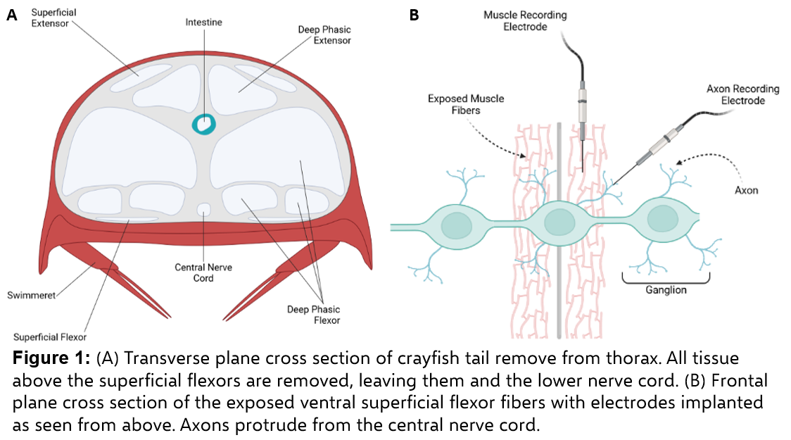

## Previous Studies

Work done by Lu Lan, PhD, and Ying Jiang, PhD established the fundamentals of using a single ring split ring resonator based on common metamaterial principles [9]. Using a copper ring of 12.7 mm in diameter with a 0.4 mm gap that resonated with a 2.27 inflicted GHz microwave, a field (albeit ultrasound in their proof-of-concept study) was generated at the gap with submillimeter spatial precision. Microwaves fill the gap between optical and radio waves, existing between 300 MHz to 300 GHz, providing 50 mm of penetration while retaining 50% of energy. The SRR resonates with incident pulsed microwaves when perpendicular to the H field and parallel to the E field (**Figure 2**). Resonance frequency red shifts with longer ring perimeters, optimizing when the ring diameter is equivalent to a half-wavelength of the microwave. Their work established the microwave can reach the SRR through obstacles with minimal scattering, forming and *LC* circuit with the metallic ring serving as the conductor and the gap serving as a capacitor.

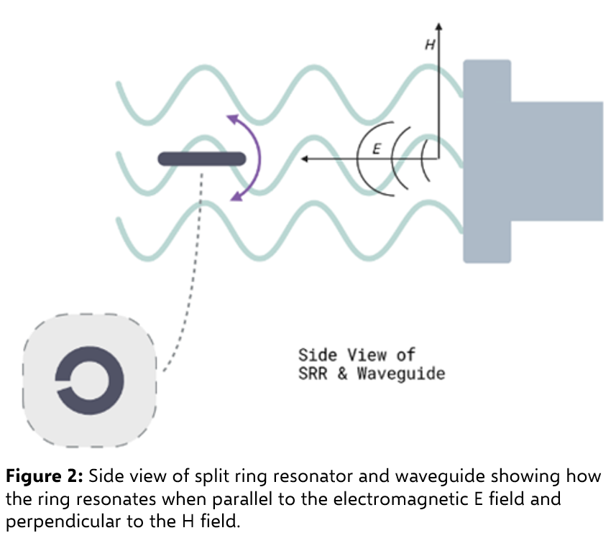

Previous studies by Carolyn Marar adjusted the operating conditions of the ring to resonate within a range of 1.9 to 2.1 GHz to generate a localized microwave field instead of an ultrasound beacon field [10]. Using neuron cultures, an inhibitory effect was seen in diminished firing rates with a titanium alloy ring 2.54 mm in diameter with a 0.2 mm gap resulting in an estimated 2 W/cm2 power concertation at the gap with a 2.0 GHz, 50 dBm microwave. Pulse profile was standardized as a 10 Hz pulse with 10 ms pulse width for 10 seconds. IEEE standard for radiofrequency exposure at 0.3 to 3 GHz is 10 W/kg averaged across 6 minutes, ~3600 J/kg, which the pulsed microwave falls well beneath at 500 J/kg using the standard pulse profile [14].

## Materials & Methods

Microwave System: A Rhode & Schwartz signal generator is used to create the base microwave, which is passed to an Agilent waveform generator to create the pulse profile. The signal is passed through a Mini-Circuits broadband amplifier powered by an external switching mode power supply to a WR-430 waveguide with an emission antenna. The waveguide is setup such that the E field oscillates perpendicular to the work surface while traveling parallel to it and the H field is perpendicular to the work surface. The standard pulse patten is 10 seconds long consisting of a 10 Hz square wave with a 10 ms pulse width.

*Procambarus clarkii* Preparation: Each preparation is made using a tail removed from the thorax, then dissected under a microscope to expose the ventral superficial flexor muscle layer adjacent to third nerve axon innervations from the central nerve cord. Dissections are pinned using cactus needles rather than metallic to avoid thermal interactions from microwave. Peristaltic pumping with saline solution is added to ensure longevity of the sample. A suction electrode filled with saline is used with the axon to record action potentials while a intracellular recording electrode filled with 3 M KCl is used to penetrate muscle fibers to record post-synaptic potentials [13]. Muscle electrodes are made using glass polished to a resistance of 10 MΩ, with the tip broken off for suction electrodes to accommodate the width of the third motor nerve loop sucked in. Setup can be configured to record using a DC and/or AC amplifier for each input that then transmits acquired signals to a PC using a National Instrument data acquisition board (USB 6221). The SRR is placed on the preparation nerve cord while the waveguide is positioned ~50 cm away. The entire setup is contained inside a copper sheet Faraday cage with grounding wires connected to all recording equipment and electrode translational stages.

Electrophysiology in IGOR Pro: IGOR Pro 9 and the IGOR Pro NIDAQ Tools package are used on acquired signals for data analysis. Analysis procedures include checks for stability, inversions, and spike sorting based on peak-to-peak amplitudes to distinguish between different axons. 30 second trace collection patterns are configurable, but typically accommodate the standard 10 Hz pulse with 10 ms pulse width for 10 seconds on alternating traces so paired analyses are run as control on the odd traces (without microwave) and even traces (experimental) where the first third is pulsed microwave. Frequency and amplitude analysis is used to compare both action potentials and post-synaptic potentials.

## Specific Aims and Proposed Studies

*Aim #1:* Verify the crayfish *ex vivo* model as a valid testing platform.

* 1. – Establish the viability of using the *Procambarus clarkii* model.

In an effort to ascertain whether experimental results will be valid using the *Procambarus clarkii* model, electrophysiology will be recorded within a mimic setup as delineated in the Inam paper [13]. Resulting data will be used to determine necessary adjustments including adding grounding to more equipment, selecting DC vs AC amplifier for the muscle electrode, and successfully recording potentials within the microwave field.

* 1. – Refactor current analysis procedures to account for microwave effect and optimize protocol.

Current analysis procedures are designed to compare drug trials that affect certain neuronal channels to understand spike mechanisms. Adjustments to these procedures will be made so that analysis can be conducted on traces alternating between applied microwave and control. Electronic artifacts associated with microwave pulses do not obscure action and synaptic potentials but require further filtering for analysis. Code will also be optimized to run on later versions of IGOR Pro to take advantage of newer functions and multi-threading CPU support to increase runtimes.

*Aim #2:* Characterize and quantify the SRR effect in the *ex vivo* model.

* 1. – Compare microwave effect between unfocused microwave and microwave-coupled SRR.

Furthering work on the SRR showing an effect when resonating with the microwave field, the initial step is to understand whether there is a significant difference in the inhibitory performance of microwaves when coupled with the SRR. Trace analysis will be compared between an experiment without the SRR in place and with to understand if there are significant differences. Additionally, comparison will be made of the noise artifact created by the microwave to determine if spike extraction can be successful after filtering instead of cutting away data. This will involve comparison of noise between a microwave applied to electrodes with a preparation, a microwave applied to electrodes, a microwave coupled to an SRR applied to electrodes, and a microwave coupled to an SRR applied to electrodes with coaxial cable sheathing.

* 1. – Measure the inhibitory effect in both action potentials and post-synaptic potentials.

To understand the inhibitory effect and quantify significant changes, traces with microwave and without will be compared to understand the effect on both action potentials and their associated post-synaptic potentials. Changes will be measured from all of the six motor axons in both amplitudes and frequency. Differences between control and experimental traces will be tested for significance using two-tailed unequal variance t-tests.

*Aim #3:* Optimize performance conditions for the split ring resonator.

3.1 – Define optimal parameters and tolerance ranges for pulse width, input power, and orientation of SRR relative to waveguide.

Currently the SRR is positioned in parallel to the E field while perpendicular to the H field, using a pulse profile of 10 Hz with a 10 ms pulse width at 2.05 GHz. After aim 2.2 is accomplished, successful inhibitory data will be compared to variations of pulse profile in the pulse width (from 1 ms to continuous) to see if pulse width has any effect on inhibition. Similar comparisons will be performed on varying the input decibel-milliwatts from the signal generator to achieve different power levels (factoring in the 48 dBm increase provided by the broadband amplifier of the microwave system) to see if inhibition is affected. Lastly, a set of experiments will be conducted with a tilted ring in increments of 10 degrees to see how much conversion efficiency is conserved through the measurement of inhibitory effect to understand the tolerance range for ring alignment. Together these parameters will be presented as the optimal performance range of the SRR to achieve significant inhibition.

## Preliminary Results and Discussion

Initial findings show the *ex vivo* model is viable. Analysis protocol has been updated to factor in microwave noise, which currently is trimmed away and a 20 second post-microwave and equivalent in control trace comparison is performed. To remove metallic substances from the microwave emission field to decrease the noise profile, a set of longer glass electrodes, a larger recording dish, and cactus spines in lieu of metal pins to secure the preparation. Optical multi-dimensional translation stages were used instead of standard biological ones to ensure electrodes would not move and successful capture of potentials would be lost. Code optimization has yielded a 56.25% decrease in runtime (48 minutes for 100 traces versus 21 minutes) by trading macros for functions and eliminating temporary variables throughout running.

Data concerning action potential changes has been analyzed while refining the model. Findings from a December 9th, 2022, recording show action potential frequency decreases in windows 5, 10, and 20 seconds after microwave is applied in multiple axons when compared with a two-tail unequal variance t-test. **Figure 3** illustrates such example measurements from the first axon. Adjustments to both data acquisition and analysis have been made since, so these findings form a baseline reference point for further refinements in the attempt to show inhibition across multiple axons in both action potentials and post-synaptic potentials.

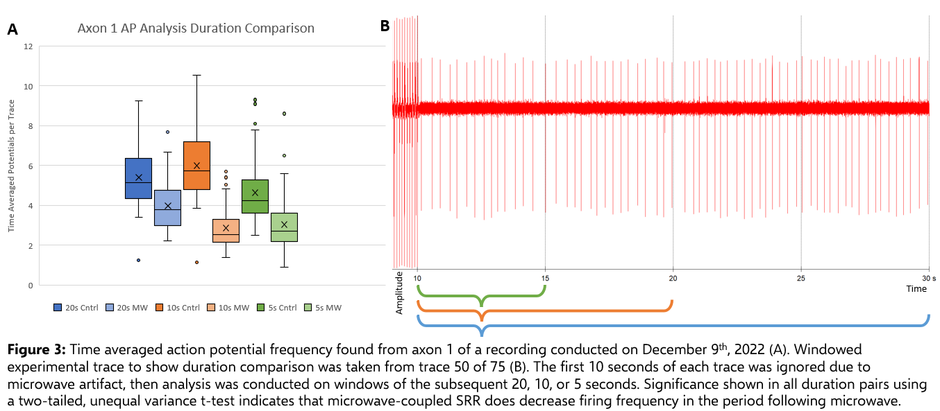

## Timeline

The experimental protocols as per the aims outlined previously has been completed or nearly completed. The remaining estimated time to completion is 2 months. The status and estimates for all aims of this proposal are outlined in Table 1.

Table 1: Expected Experimental Timeline

|  |  |  |  |
| --- | --- | --- | --- |
| Aim | Description | Estimated Time | Status |
| 1.1 | Establish the viability of using the *Procambarus clarkii* model. | June 2022 – September 2022 | Completed |
| 1.2 | Refactor current analysis procedures to account for microwave effect and optimize protocol. | September 2022 – April 2023 | In Progress |
| 2.1 | Compare microwave effect between unfocused microwave and microwave-coupled SRR. | August 2022 – April 2023 | In Progress |
| 2.2 | Measure the inhibitory effect in both action potentials and post-synaptic potentials. | August 2022 – May 2023 | In Progress |
| 3.1 | Define optimal parameters and tolerance ranges for pulse width, input power, and orientation of SRR relative to waveguide. | May 2023 – June 2023 | Planned |

## Acknowledgements

Funding support for this research was provided by the Boston University Ignition Award given to Dr. Chen Yang, the Army Research Office (ARO) grant given to Dr. Chen Yang, the National Institutes of Health (NIH) Exploratory/Development Research Grant Award (R2) given to Dr. Ji-Xin Cheng, and the National Science Foundation (NSF) 1707865 grant given to Drs. Yoshio Okada and Jen-Wei Lin. In addition to my committee, I would like to thank Dr. Feiyuan “Franny” Yu, Carolyn Marar, and Dr. Linli Shi for their contributions to this project. I would also like to thank the teams at the Yang lab, Cheng lab, and Lin lab for their support.

## References

1. Cavalli, E., et al., *The neuropathic pain: An overview of the current treatment and future therapeutic approaches.* Int J Immunopathol Pharmacol, 2019. **33**: p. 2058738419838383.

2. Colloca, L., et al., *Neuropathic pain.* Nat Rev Dis Primers, 2017. **3**: p. 17002.

3. Yang, X., et al., *Nanotechnology Enables Novel Modalities for Neuromodulation.* Advanced Materials, 2021. **33**(52): p. 2103208.

4. Chen, J., et al., *The α2δ-1-NMDA Receptor Complex Is Critically Involved in Neuropathic Pain Development and Gabapentin Therapeutic Actions.* Cell Reports, 2018. **22**(9): p. 2307-2321.

5. Kapural, L., et al., *Multicenter, Double-Blinded, Randomized, Active-Sham Controlled Clinical Study Design to Assess the Safety and Effectiveness of a Novel High Frequency Electric Nerve Block System in the Treatment of Post-Amputation Pain (The QUEST Study).* J Pain Res, 2022. **15**: p. 1623-1631.

6. Kalia, H., et al., *Application of the novel Nalu™ Neurostimulation System for peripheral nerve stimulation.* Pain Manag, 2022. **12**(7): p. 795-804.

7. Chail, A., et al., *Transcranial magnetic stimulation: A review of its evolution and current applications.* Ind Psychiatry J, 2018. **27**(2): p. 172-180.

8. Ausra, J., et al., *Wireless, battery-free, subdermally implantable platforms for transcranial and long-range optogenetics in freely moving animals.* Proc Natl Acad Sci U S A, 2021. **118**(30).

9. Lan, L., et al., *Ultraefficient thermoacoustic conversion through a split ring resonator.* Advanced Photonics, 2020. **2**(3): p. 036006.

10. Marar, C., et al., *Wireless Neuromodulation at Submillimeter Precision via a Microwave Split-Ring Resonator.* bioRxiv, 2022: p. 2022.07.22.501150.

11. Akhmedov, K., B.M. Kadakkuzha, and S.V. Puthanveettil, *Aplysia Ganglia preparation for electrophysiological and molecular analyses of single neurons.* J Vis Exp, 2014(83): p. e51075.

12. Zhuo, J., et al., *Use of an invertebrate animal model (Aplysia californica) to develop novel neural interfaces for neuromodulation.* Frontiers in Neuroscience, 2022. **16**.

13. Inam, Z.S., S.K. Nelamangala, and J.W. Lin, *Application of a spike sorting procedure to analyze recordings in the crayfish ventral superficial flexor preparation: A high resolution approach to the study of neuromodulators on axons and synapses.* J Undergrad Neurosci Educ, 2014. **12**(2): p. A140-9.

14. Lin, J.C., *A new IEEE standard for safety levels with respect to human exposure to radio-frequency radiation.* IEEE Antennas and Propagation Magazine, 2006. **48**(1): p. 157-159.